

**UNIVERSITY OF PETROLEUM AND ENERGY STUDIES**

**School of Computer** **Science**

**2020-21**

**GRAPHICS AND ANIMATION TOOLS LAB**

**Faculty: Dr. DURGANSH SHARMA**

**Assistant Professor**

**Department of Cybernetics.**

**School of Computer Science, UPES**

**Submitted By:**

**Name- Ishita J Karmakar**

**Roll no-R100217107**

**Batch-B3**

**Semester- 7**

**Course-B.Tech CSE-OSOS**

**SAP ID- 500064067**

**EXPERIMENT NO 7**

**Aim** :- Design a 3D Rocket using Blender.

**Objective** :- To Design a 3D Rocket using features of Blender 2.8.

**STEPS TO MAKE DESIGN A 3D ROCKET: -**

1. Open Blender workspace delete the existing cube and Click on the add option and add cylinder.
2. Then we will make some adjustments in the cylinder like radius and depth, we will set the depth and radius as 2m.
3. Then add a mesh and choose cone, for the tip of the rocket.
4. Similarly, by adding cube mesh we will create the fins of rocket, by extruding and adding subdivision modifier, we will make the fins smoother.
5. To give fire effect that will be released from rocket we will first add the icosphere at the bottom of the rocket.
6. Then go to the object option and then select quick smoke under quick effects option. After this change the smoke option to smoke+fire option.
7. After this add wind under the force field option.

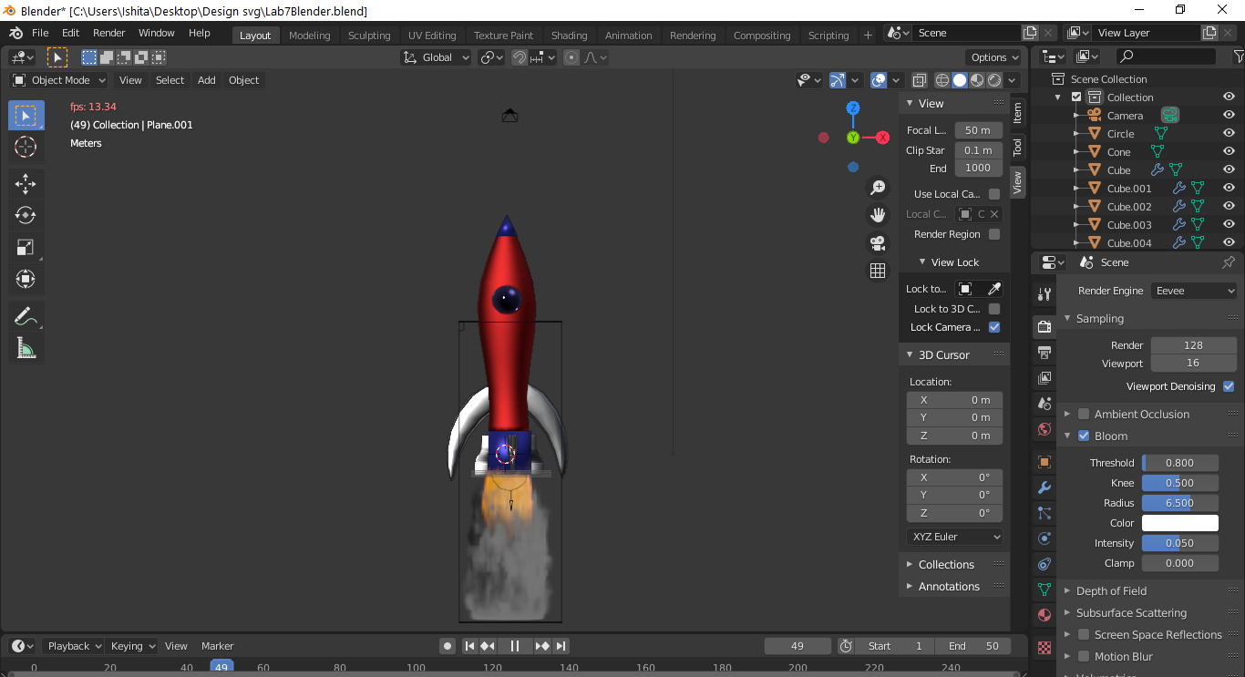

1. At last create three material colors red, silver and blue and add metallic property to them. Reduces or increase roughness according to your need.
2. Select a particular part of rocket and assign a suitable color to it.

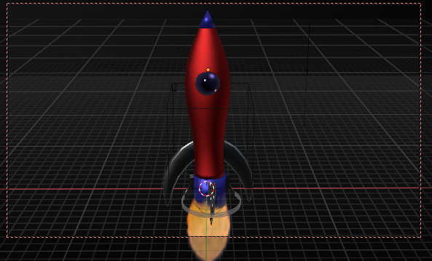

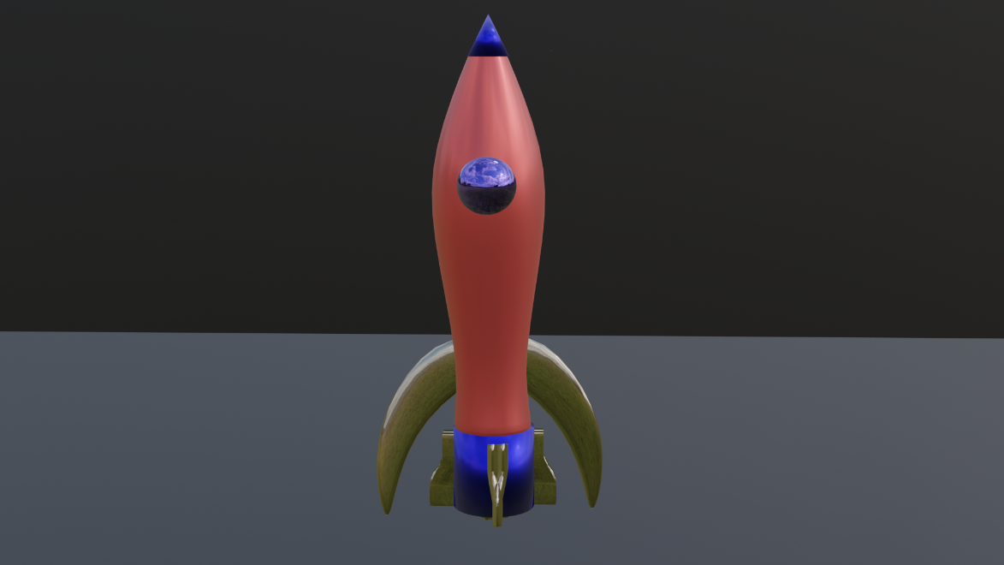

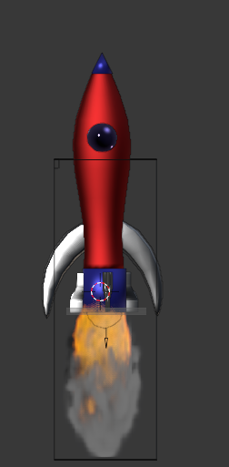

Link for Google Drive: - <https://drive.google.com/drive/folders/1GbmStyz1RjT3s-kg0gcerTnO-oQUz0rv?usp=sharing>